**Syria's toxic war on itself**

**- Pragya Bhatnagar, Eudora Wang Qian, Tiffany Leung, Daisy Zhong & Yan Yang**

The Middle Eastern nation Syria has been in a state of civil war since last seven years with different groups trying to seize control of the country.The country has become an international battleground where various states and their proxy networks have been continuously clashing with each other. The war has taken the lives of more than 465,000 people so far and displaced more than 12 million, of which 6 million refugees have been dispersed around the world.

**About Datasets**

**A media documentation -- the Syrian Archive Dataset** is an open source platform that collects, curates, verifies, and preserves visual documentation of human rights violations in Syria. It maintains an extensive video database of all known allegations in which civilians have been reported killed or injured since 2014. Till April 20, 2018, this database includes 4,384 videos which were documented by journalists, citizen reporters and activists.

**A recorded death list -- the Violations Documentation Center in Syria** is one of the largest human rights organisations established in 2011 with staff members and contacts in all governorates and most cities inside Syria.

The complex nature of the war in Syria limits access to open database. And therefore, the data extracted could miss some important information; however, we will be analyzing the situation in Syria with precision by filling some of the gaps with the help of other dataset.

In the morning of April 14, 2018, the US, Britain and France bombarded three government sites in Syria allegedly targeting the chemical weapons facilities. Is it true that Syria has been continuously suffering from its internal turbulence which need to be intervened by foreign players?

We drew a general picture of violations happened inside Syria based on the datasets of the Syrian Archive and the Violations Documentation Centre in Syria which were recorded from February 26, 2016 to April 20, 2018.

**Part 1 General Picture**

**Living Hell**

In the war-torn country, Aleppo, Damascus, Idlib, Homs and Hama are the cities documented by both the databases as the locations where most violations took place, despite some slight differences on the rankings of these locations.

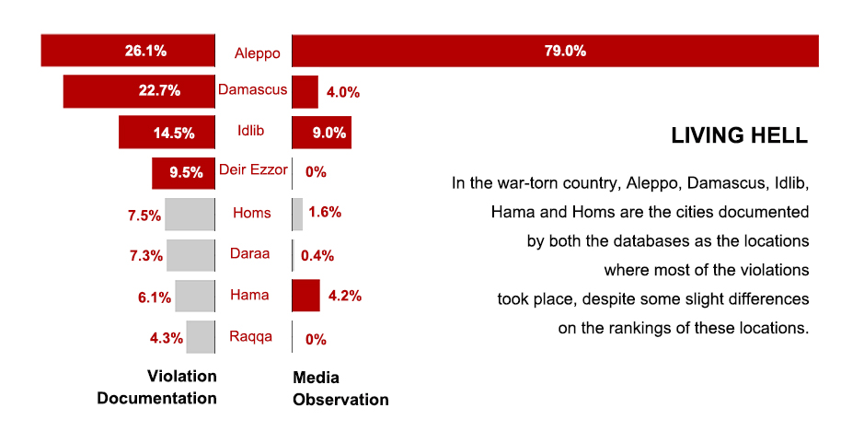

▲ The media coverage on the locations where most violent incidents happened are highly identical to the locations recorded in the actual death list.

To be specific, the Syrian Archive, which demonstrates media coverage, witnesses most violations in Aleppo (1,920), followed by Idlib (219), Hama (103), Damascus (97) and Homs (39).

The Violations Documentation Centre of Syria, which records the actual registered death list, also presents Aleppo (7,990) as the most violation prone city in Syria. Damascus (6,372) stands tall at second. Idlib (4,434) is also prominent in violent incidents. And Deir Ezzor (2,904), a city which was absent in the media coverage database, ranks fourth in the media documentation.

In terms of geographic distribution of the violent incidents in Syria, Aleppo and Idlib are the two cities ranking among the tops in both the datasets and have been the most disputed regions taken up by either rebels or jihadists, thus these are the areas where the Syrian regime and its allies have been concentrating their firepower.

**Chemical Weapons: Excuse or Reality?**

Given the reason that the Syrian regime has been constantly using chemical weapons in the civil war, the three countries namely the US, Britain and France launched missile attacks on Damascus in early April. Interestingly, this is a city which is currently occupied by the Syrian government. However, the major cause of death recorded in the database provides a different picture altogether.

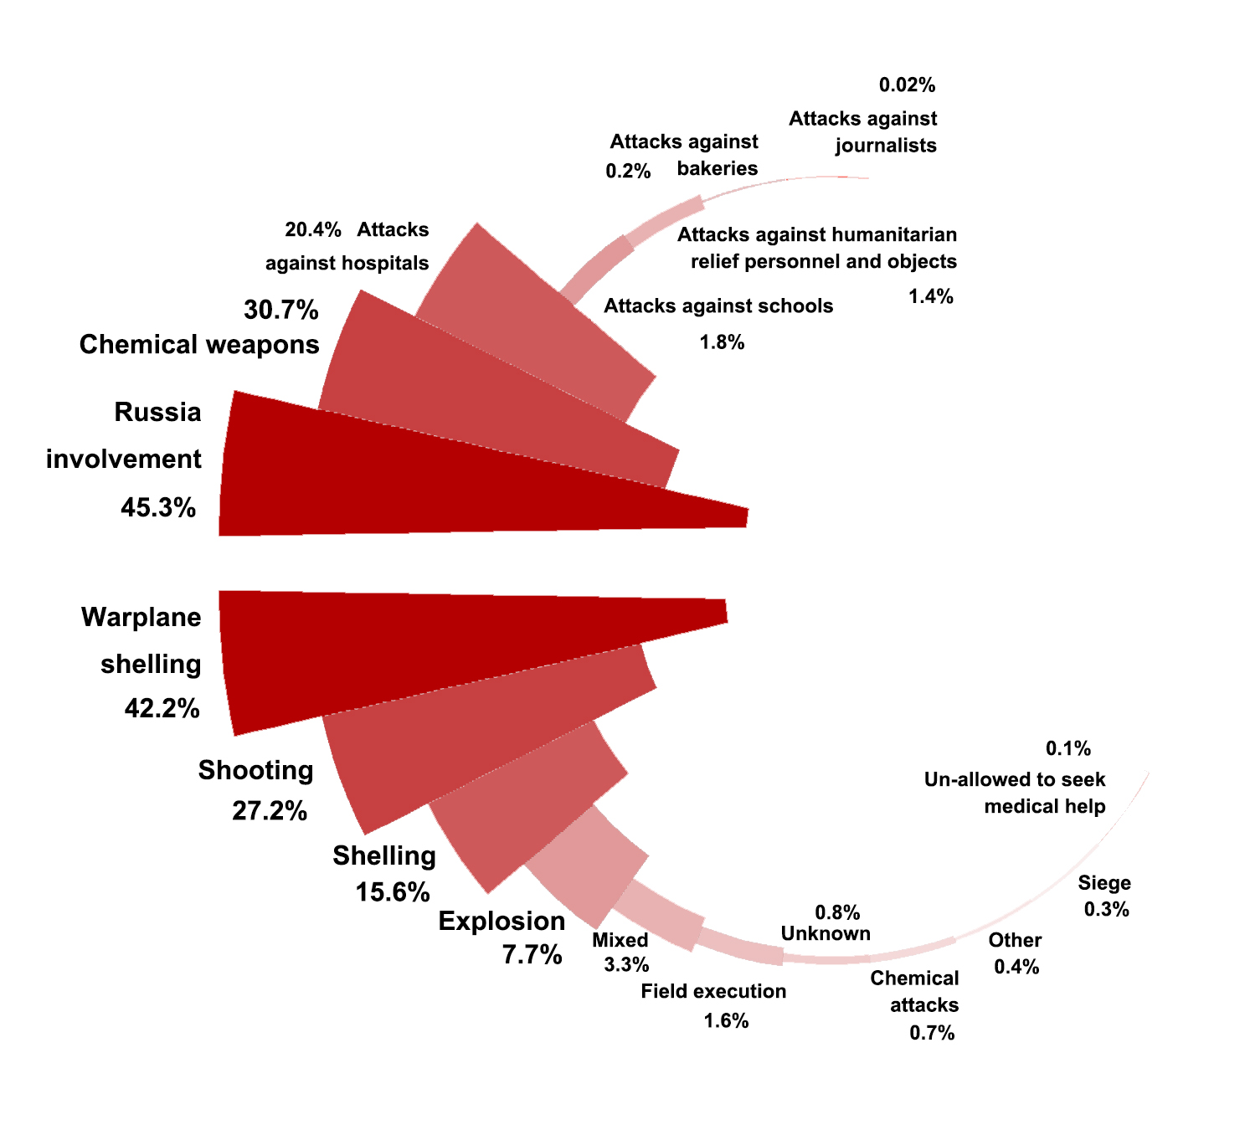

▲ “Chemical weapons” is attributed as the second major cause of death in the media documentation, while the recorded death list takes it as a trivial factor.

According to the Violations Documentation Centre in Syria, warplane shelling (12,926) leads the cause of death, followed by shooting (8,348), while chemical weapons, i.e. chemical and toxic gases (226) as classified in the database, resulted in a relatively small amount of death, taking up about 0.7% among all the reasons.

On the contrary, the media coverage documented in Syrian Archive has been following the agenda set by the official claims since it attributes 158 of the 514 violent incidents (30.7%) to chemical weapons, ranking it as the second factor that has been taken lives of thousands of people in Syria.

The contrast demonstrates a gap between the actual causes of death and the attributions given by sources in the media reports. This suggests that human rights investigators, advocates, media reporters who have been working with the Syrian Archive and making efforts to document human rights violations in Syria, may need to be cautious with the official claims deliberately disseminated by different stakeholders, staying alert and objective while reporting and recording on the land of disputes.

**Who is the culprit?**

The Syrian civil war is a result of both internal and external factors. There are three wings fighting each other which have led to mass destruction and humanitarian crisis in the country. One side is led by the Syrian government backed by its allies namely Iran, Russia and Hezbollah. The second front includes international participants such as Turkey, Saudi Arabia backed rebels such as Syrian national Coalition, al-Nusra Front and the Army of Conquest, while the third side includes terrorist organization of the Islamic State in Iraq and the Levant (ISIS).

A few minor troops are also involved in the wage war against the ruling government such as People’s Protection Units, who have been importing supplies and munitions from the US.

The jumble of forces breeds the gray area in the civil war where various fractions feel secure to launch indiscriminate attacks as they sling mud on one another for the killings taking place in the country.

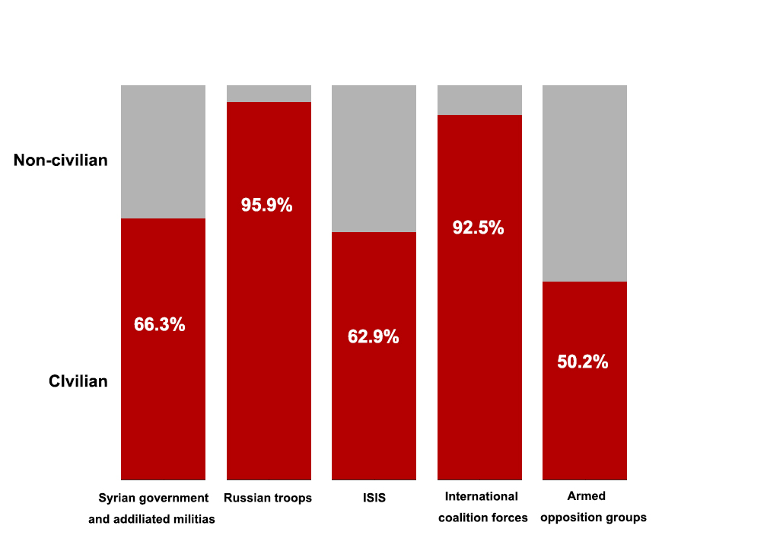

▲ The proportion distributions of civilian and non-civilian victims in violations conducted by various fractions.

Since February 26th, 2017 to April 20th, 2018, 30,653 people died in Syria due to identified attacks by various groups, as per Violation Documentations Centre in Syria.

The top butcher in the war has been the Syrian government and its affiliated militias (15,580), of which 10,324 civilians have been killed accounting for 66.3 percent.

Interestingly, Russia has also been named in the database as comprising large number of killings in Syria. Putin-led government has committed 3,808 murders in the past two years with a striking proportion of civilians being **95.9 percent** (3,651), accounting for 11.9 percent of the total deaths in the country.

The terrorist group, ISIS, stands third (3,102), resulting in 1,950 civilians (62.9 percent) deaths under their sleeves. The fourth one is the international coalition forces (2,059) and the fifth one is armed opposition groups(1634) who behaves hardly better than its counterparts in terms of minimizing civilian casualties (50.2 percent).

The frequent mentions of “Russian troops” implicate the myriad connection between the two countries which is also presented in Russia’s response on the missile strikes led by the U.S.

**Russian Intervention**

On April 14th, 2018 -- hours after the missile attacks in Syria carried out by the three countries -- Russia warned that there would be consequences, which as the Kremlin put it, could be the state-of-the-art air defense system, the S-300 surface-to-air missile.

“A few years ago at the request of our partners, we decided not to supply S-300s to Syria,” Sergei Lavrov, Russian Foreign Minister told BBC in an interview on April 16.

“Now that this outrageous act of aggression was undertaken by the US, France and UK, we might think how to make sure that the Syrian state is protected,” he said, adding that the plan might be revived because Russia feels it must do “whatever is required to help the Syrian army deter aggression.”

The S-300s surface-to-air missile can fire at six targets simultaneously and cover a range of 200 kilometers (120 miles). The deployment of S-300s in Syria has been a concern for two decades. Russia already sold S-300 systems to Iran over American and Israeli objections. And Syria was on track to get them too, until 2013 when Russian President Vladimir Putin froze the contract in response to pleas from Israel.

Youtube: <https://youtu.be/u2qN1YcY0-A>

▲ The capabilities of the modernized S-300PMU-2 "Favorit" variant.

(Source: Zvezda, the Russian Ministry of Defense's official television channel)

Russia’s intervention in the Syrian Civil War began in September 2015 after an official request by the Syrian government for military aid against rebel and jihadist groups.

The intervention initially consisted of air strikes fired by Russian aircraft stationed in the western coastal Khmeimim base at targets primarily in north-western Syria against militant groups opposed to the Syrian government.

On January 18th, 2018, Syria and Russia signed a deal aiming at expanding the Tartus naval facility, Russia’s only naval foothold in the Mediterranean, and granting Russian warships access to Syrian waters and ports as a solid step for Russian troops to permanently play a role in Syria.

**Death Knocks**

As the most powerful outside actor, Russia is increasingly being blamed for the misery inflicted on Syrian civilians.

Thousands of deaths and casualties were a result of Russian warplanes striking the Syrian land. [The Syrian Observatory for Human Rights](http://www.syriahr.com/en/) documented the death of 17,183 civilians and fighters of the opposition camps since the start of Russian intervention in September 2015 until March 30th, 2018. Among them, about 7,700 citizens, roughly 45% of the death toll recorded in the 30 months, were caused by the Russian warplanes.

According to Violation Documentations Centre in Syria's data, from February 26, 2016 to April 20, 2018, only every one out of the 24 killings by Russia has been precisely targeted against non-civilians.

Opposite to the fact that Russian troops failed to take necessary precautions to avoid and minimize civilian casualties, their munitions such as warplane shelling and explosion were well-targeted at locations where they could extract the most benefit.

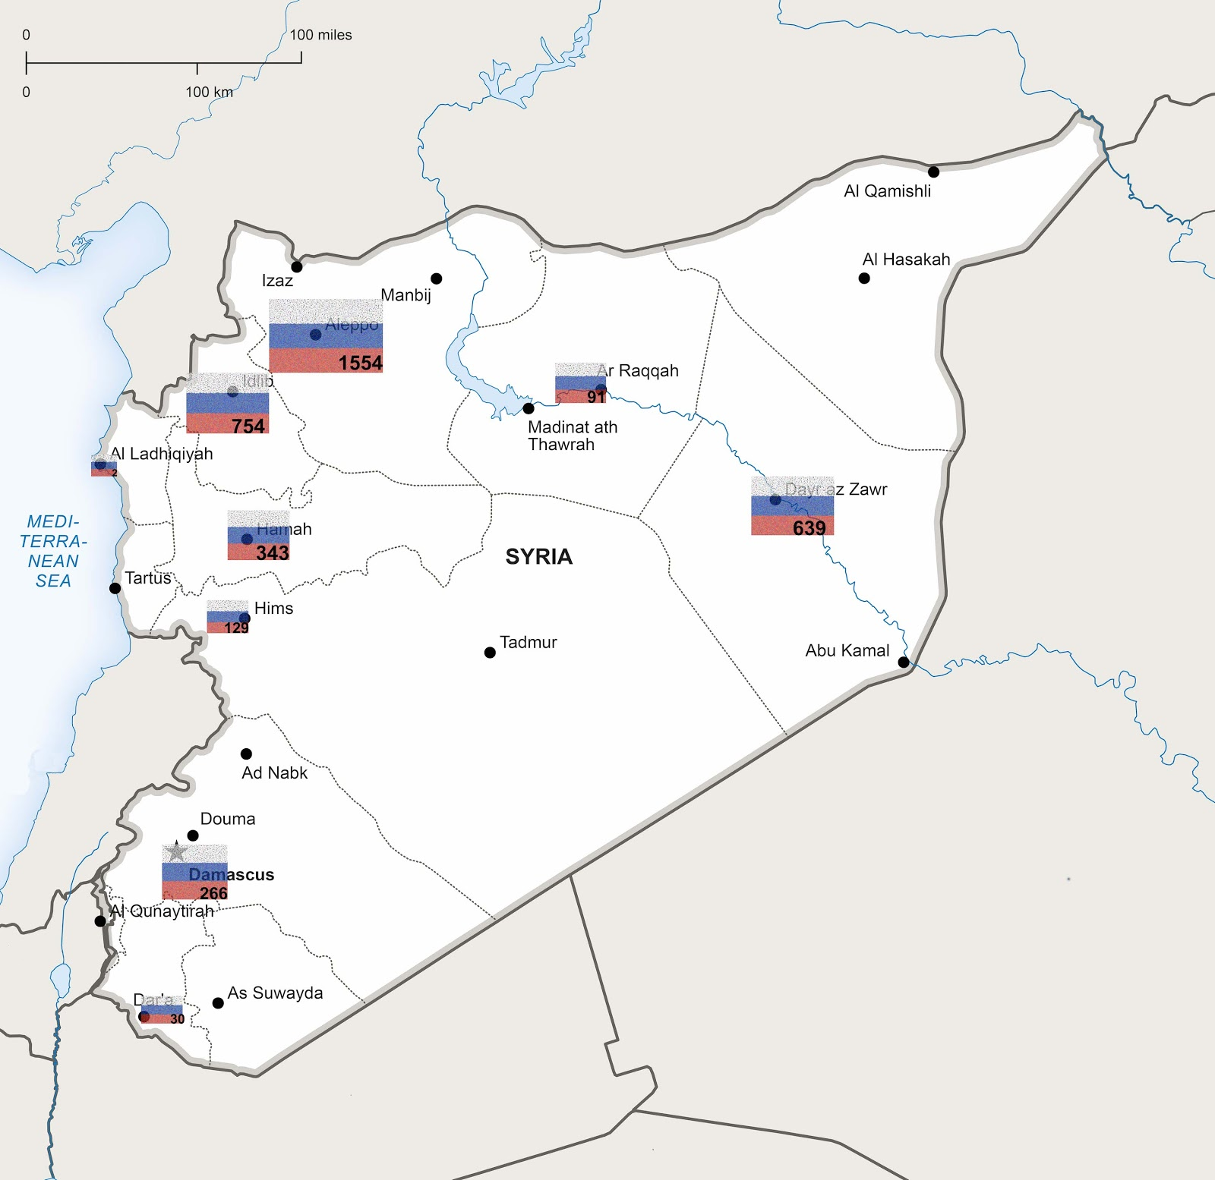

▲ Russian munitions have been well-targeted at locations where they held the largest benefits.

Besides Aleppo (1,554) and Idlib (754), where the rebels and jihadists have fiercely attacked, Deir Ezzor, the third city on the list where 639 lives were taken by Russia, is a strategic area for all the forces to capture.

Deir Ezzor is the largest city in eastern Syria and the seventh largest in the country. The city has a domestic and international terminal and it is an important hub as it connects with Damascus and destination in the Persian Gulf region.

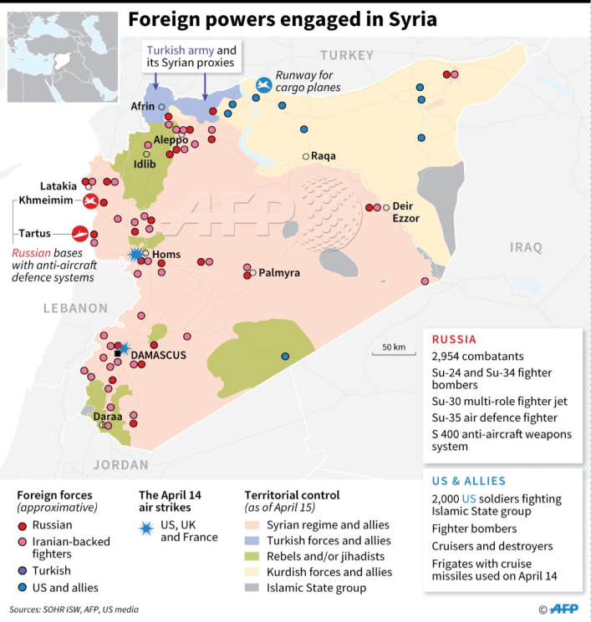

▲ Foreign powers engaged in Syria

(Source: AFP / April 15th, 2018)

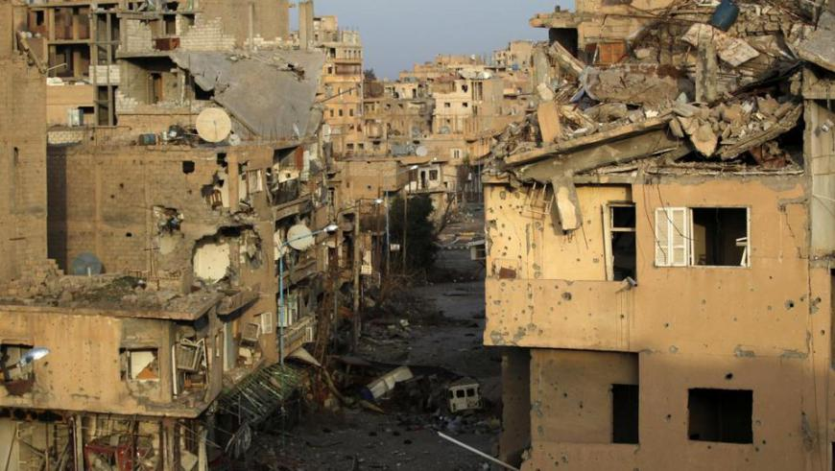

▲ The strategic region of Deir Ezzor is split by Russia, the regime-backed groups and the US-backed People’s Protection Units. (Source: Reuters)

“The Syrian regime, in the long run, would like to control all of their territories, [so] the Syrian regime is looking for ways to control [Deir Ezzor],” said Ozgur Unluhisarcikl, the director of the German Marshall Fund’s Ankara Office in an [interview](https://www.trtworld.com/middle-east/are-us-russia-tensions-in-deir-ezzor-really-about-territory--15487) with TRT World.

As shown in the map of foreign powers engaged in Syria, Deir Ezzor has been split between the Russia-and-Iran-backed regime and the People’s Protection Units, a mainly-Kurdish militia provided by America with [close air support](https://edition.cnn.com/2014/10/08/world/meast/isis-threat/index.html). Despite the US and Russia have been holding “deconfliction” meetings to prevent confrontations, the oil-rich region has seen some episodes of conflict between the two sides.

Russian troops’ frequent activities in Deir Ezzor helps the Syrian government to retake territory from various anti-government groups, but meanwhile it bears a broader geopolitical objective, which is to roll back U.S. influence.

This explains why most Russia’s intervention happened in areas like Deir Ezzor, and Idlib, a city in northeastern Syria, currently controlled by Rebels and Jihadists and has always been a focus of protests and fighting since the early phase of the Syrian civil war.

**Untraceable Trade**

Russia, an ally adamant in its position to support Damascus by wielding its veto for Syria, has a close connection with this war-torn country not only militarily but also commercially with some arms trade and trade on other products traceable at least in the early years.

In 2016, Russia ($186M) was the fifth largest import origins of Syria while the other four include Turkey ($1.38B), China ($1.02B), Egypt ($237M) and South Korea ($209M), according to the latest statistics visualized by the [Observatory of Economic Complexity](https://atlas.media.mit.edu/en/), a website that composes a visual narrative about countries and the products they exchange, based on the data provided by open sources including [UN Comtrade Database](https://comtrade.un.org/), [BACI International Trade Database](http://www.cepii.fr/CEPII/en/bdd_modele/presentation.asp?id=1) and [The Center for International Data](http://cid.econ.ucdavis.edu/).

Even though the four percent trade value shared by Russia does not seem to be significant, the trade products exported from the country in 2015 contains more than a quarter of arms and ammunition, which has no presence in any of the other four countries’ exports.

As presented in the graph below, the $27.4 million-worth chemical products and the $24.2 million-worth explosive ammunition are the top products exported from Russia to Syria in 2015. The total transaction is divided into 13 percent of explosive ammunition, 6.5 percent of propellant powders, and 6.1 percent of prepared explosives and some other war-related supplies.

Looking into the Russian exports in 2016, there are discrepancies as only 1.2 percent of prepared explosive was recorded in the tiny cluster of chemical products. Besides, a chunk of gray area (55 percent) as shown in the graph, has been tagged as “Unspecified”.

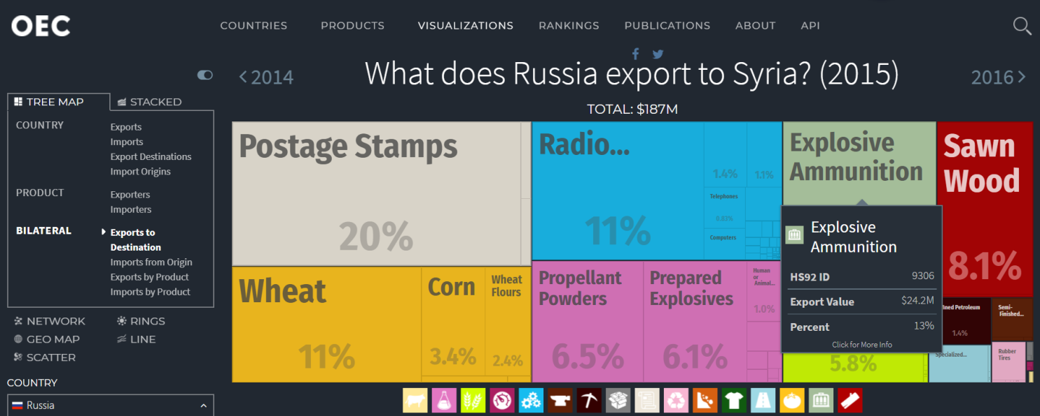

▲ What does Russia export to Syria in 2015?

(Source: [Observatory of Economic Complexity](https://atlas.media.mit.edu/en/visualize/tree_map/hs92/export/rus/syr/show/2015/))

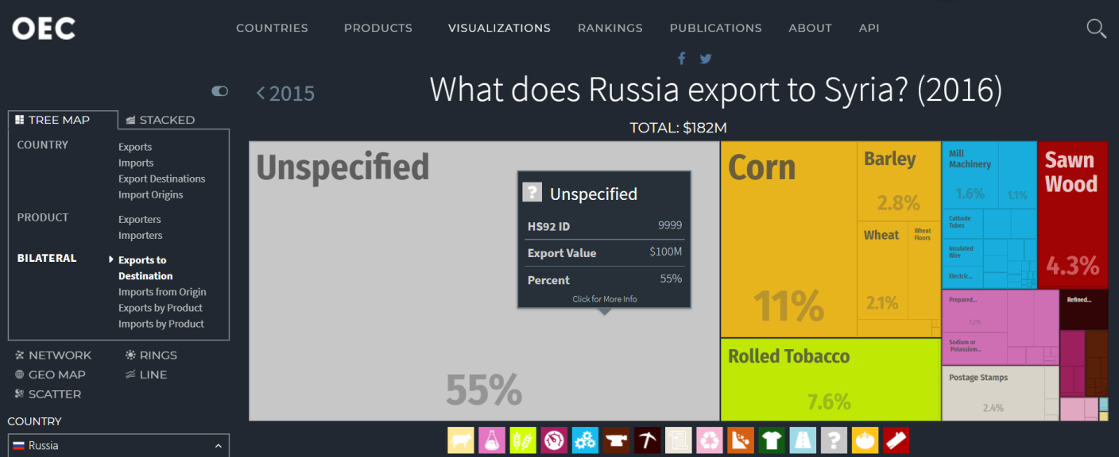

▲ What does Russia export to Syria in 2016? Fifty-five percent products imported from Russia to Syria are “unspecified”.

(Source: [Observatory of Economic Complexity](https://atlas.media.mit.edu/en/visualize/tree_map/hs92/export/rus/syr/show/2015/))

The transaction in weapons became untraceable because a temporary cessation of hostilities has taken into effect since February 26, 2016. The truce agreement only involves Syrian government and rebel forces, but not the so-called Islamic State group and the al Qaeda-linked Nusra Front, calling for all involved parties to cease to use weapons or to gain territory; and to give relief organizations access to disputed territories so they can assist civilians.

The truce agreement, however, did not meet the faithful implementation of the Russian troops since the Syrian Archive recorded 220 out of 230 incidents of “unlawful attacks” carried out by Russia in the duration of our research.

Moscow has effectively tied its fortunes to those of Syrian President Bashar al-Assad, with limited room to maneuver. As put by Neil MacFarquhar, the Moscow bureau chief for The New York Times:

*“Putin can neither withdraw nor push real political change in Syria without risking the collapse of the Assad government, which would jeopardize both the effort to diminish American influence in the region and his own prestige.”*

**References**

1. Syrian Network for Human Rights

<http://sn4hr.org/blog/category/report/special-reports/russian-force/>

2. Violation Documentation Centre in Syra

<http://www.vdc-sy.info/index.php/en/martyrs/1/c29ydGJ5PWEua2lsbGVkX2RhdGV8c29ydGRpcj1ERVNDfGFwcHJvdmVkPXZpc2libGV8ZXh0cmFkaXNwbGF5PTB8c3RhdHVzPTF8NT1SdXNzaWFufA==>

3. Map library of conflicts in Syria, University of Texas Libraries

<https://legacy.lib.utexas.edu/maps/syria.html>